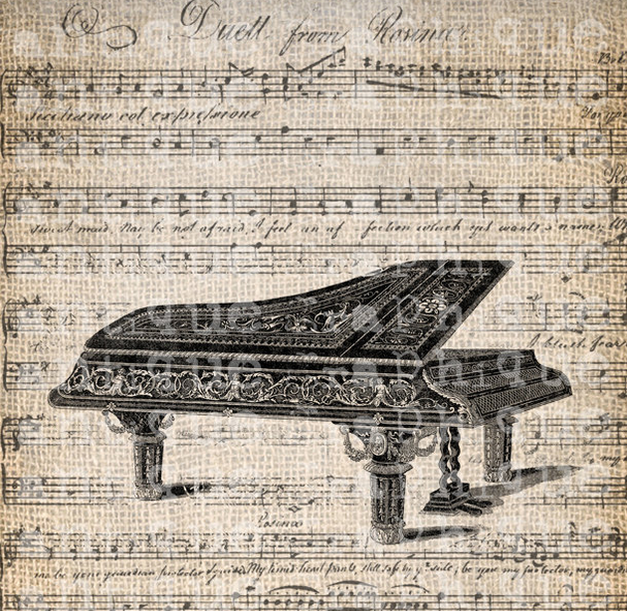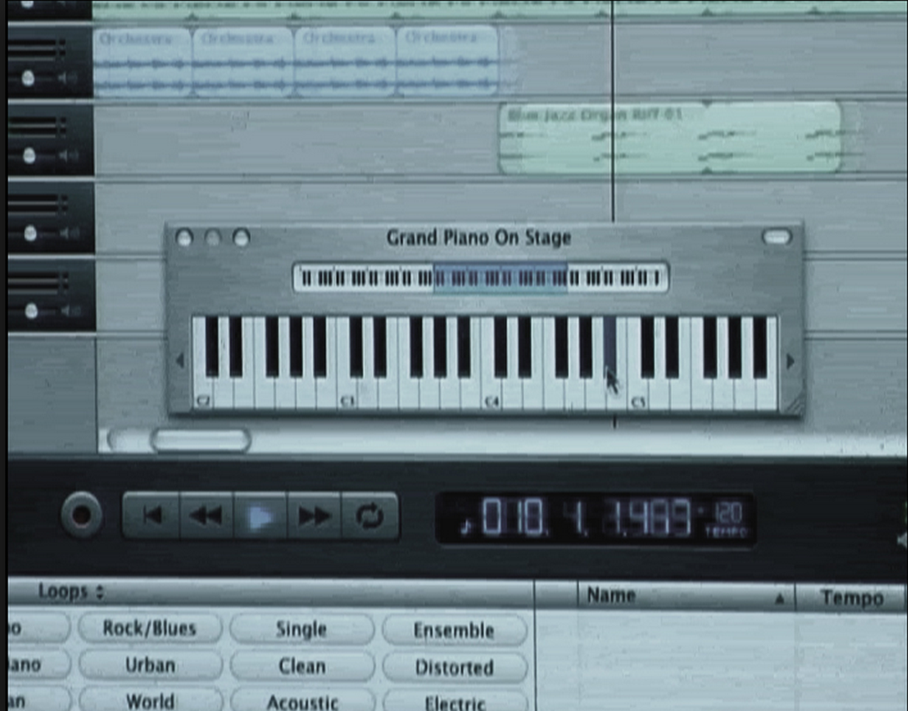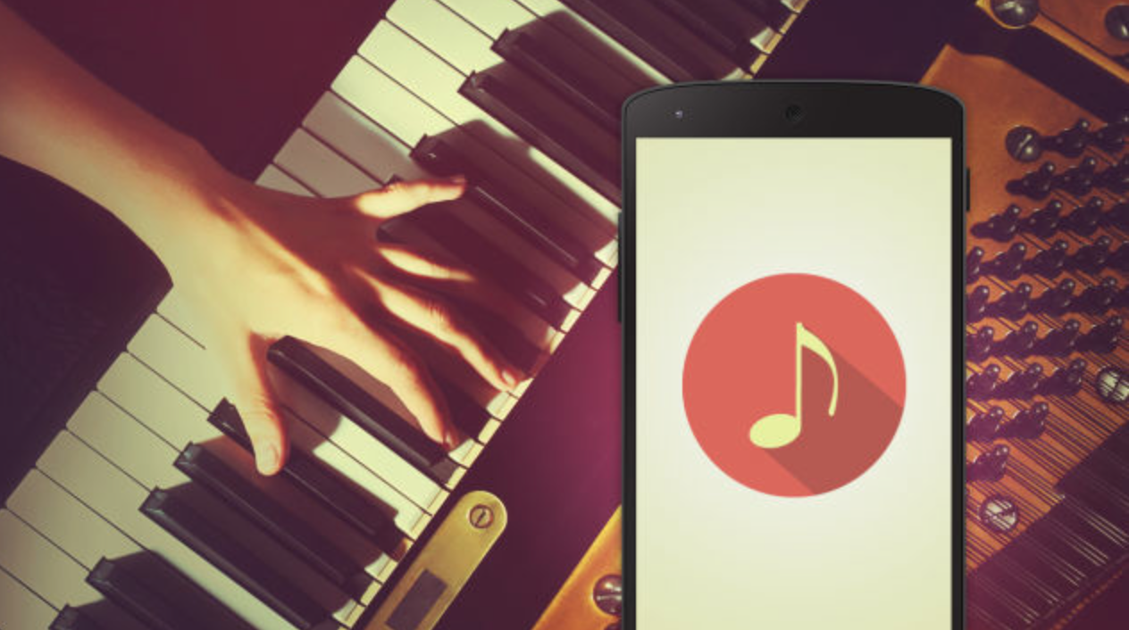

Team name: KillDash9

Level: Apollo

Sadhika Billa  
Thenaesh S/O N Elango

Orbital, 2015: Ideation

Rhythm

Rhythm is a web application that uses code to generate score sheets and once the code compiled, it allows the user to play it back instantly. Additionally, it enables users to put their name to the music and share it with other users. Users don’t have to know how to play the instruments, nor do they require extensive knowledge of music theory.  
  
Our application is catered towards individuals who love to code as well as enjoy making music.

Almost all music making and production apps that are currently available (Drum Perfect, CAUSTIC 3, SunVox etc.) only allow users to manually use keys to adjust the frequency and sequence of sounds. Rhythm is unique in that it makes use of code to allow users to place notes in the required position rather than simply do it manually.

# What exactly is Rhythm, who is it for and how is it different from other web applications?

User Stories

Libraries

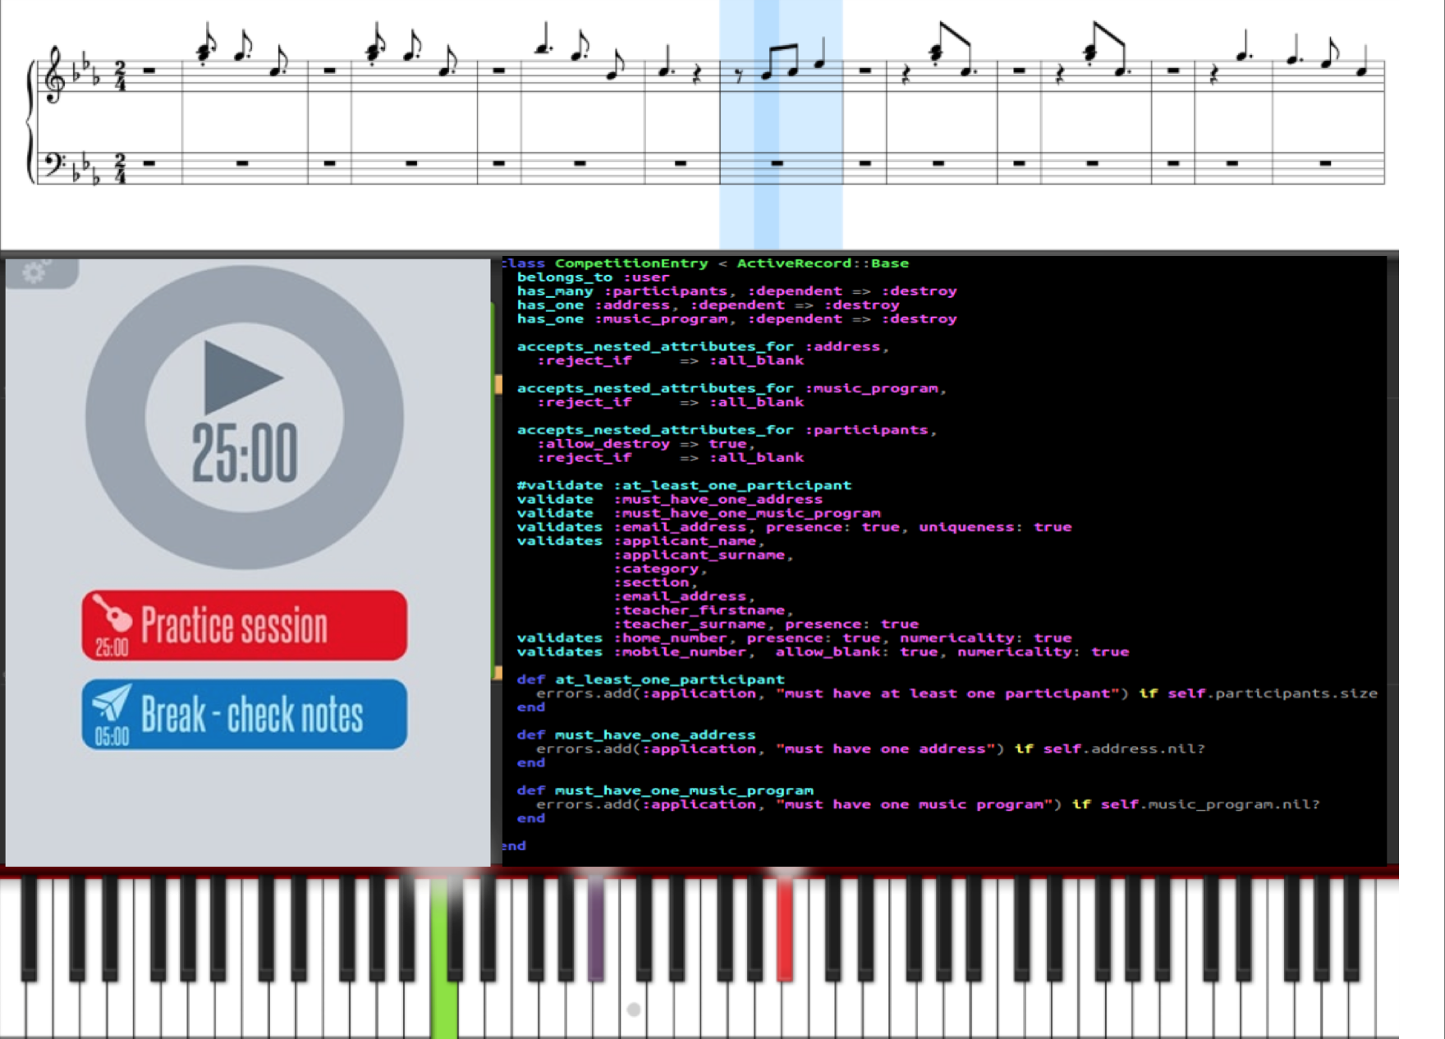

Layout